Task 4: Say I own 857 CDs. My friend has written a computer program that uses a webcam to scan the shelves in my house where I keep my CDs and measure how many I have. His Program says that I have 863 CDs. Define measurement error. What is the measurement error in my friend’s CD counting device.

Measurement error is the difference between the true value of something and the numbers used to represent that value. In this trivial example, the measurement error is 6 CDs. In this example we know the true value of what we’re measuring; usually we don’t have this information, so we must estimate this error rather than knowing its actual value.

Task 5: Sketch the shape of a normal distribution, a positively skewed distribution and a negatively skewed distribution.

## Negative or Left Skewness
x = rbeta(10000,5,2)
hist(x, main="Negative or Left Skewness", freq=FALSE)
lines(density(x), col='red', lwd=3)
abline(v = c(mean(x),median(x)), col=c("green", "red"), lty=c(2,2), lwd=c(3, 3))
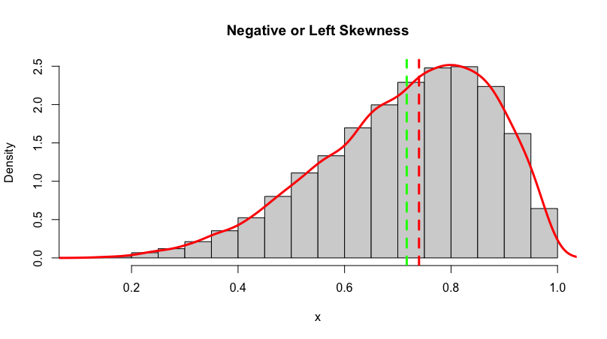
## Positive or Right Skewness
x = rbeta(10000,2,5)
hist(x, main="Positive or Right Skewness", freq=FALSE)
lines(density(x), col='red', lwd=3)
abline(v = c(mean(x),median(x)), col=c("green", "red"), lty=c(2,2), lwd=c(3, 3))

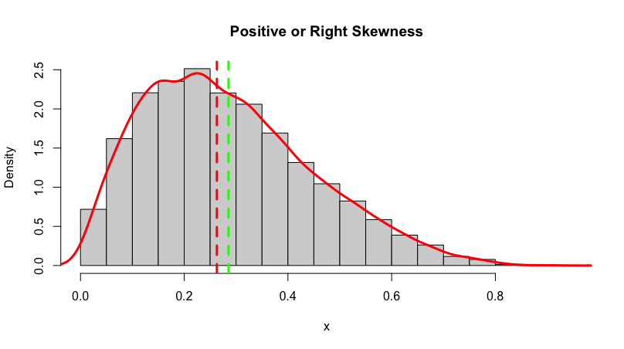

## Symmetrical
x = rbeta(10000,5,5)
hist(x, main="Symmetrical", freq=FALSE)
lines(density(x), col='red', lwd=3)
abline(v = c(mean(x),median(x)), col=c("green", "red"), lty=c(2,2), lwd=c(3, 3))

